
MUSTAFA KEMAL UNIVERSITY
6TH ERASMUS+ STAFF WEEK
19 - 23 October 2015

GENERAL INFORMATION

AIM OF THE EVENT

Our main goal to organize the 6th Erasmus Staff Week is to create an opportunity for our partners to introduce their universities, to learn about Turkey and Turkish culture, and to share experiences with others while carrying out Erasmus Teaching or Training activity in the frame of Erasmus+ Staff Exchange program. A five-day program was planned with this aim.

Any academic or administrative staff working at our partner universities or other European universities willing to make new collaboration can apply for the 6th Erasmus Staff Week which will take place in Antakya, Hatay, Turkiye in 19-23 October 2015.

APPLICATION

Maximum of three staff from each university will be accepted to the event, but this limitation may change depending on the number of applications. Because of this, anyone willing to join the event may send an application. The total number of participants will be limited to 20 people.

Those willing to join the event should download the application form from the International Office’s web site (http://int.mku.edu.tr, Erasmus menu) and then fill in the Application Form and send it to erasmus@mku.edu.tr and mkuerasmus@gmail.com by e-mail. It is not necessary to send the Application form by regular mail.

The status of the application will be determined within about one week after the application form is received. A letter of invitation will be sent to the staff whose application is accepted.

COSTS

There is no participation fee for the program. Participants should cover their travel and accommodation costs. Costs for the excursion, transportation, lunches, and dinners mentioned in the program will be covered by the Mustafa Kemal University International and Erasmus Office.

Participants may contact their university’s Erasmus Office to obtain Erasmus+ program staff mobility grants to cover the costs.

LANGUAGE

The language of the event is English. We require sufficient knowledge of English from all participants.

ABOUT ANTAKYA AND HATAY

Hatay is one of the 81 provinces of Turkey. It is located in the mid-south of Turkey. Antakya is the central city of the Hatay province. The main campus is located in 15 km north of the Antakya city center and about 10 km south of the Hatay international airport (please see the map below). Antakya is famous for cultural and historic assets (mainly mosaic artifacts), St.Peter’s grotto church, Turkish and middle eastern cuisine, and beaches.

TRANSPORTATION

Hatay has an international airport which is about 25 km north of the Antakya city center and 10 km north of the Mustafa Kemal University Main Campus. The Main campus named “Tayfur Sökmen Campus” is between Antakya city center and the airport (please see the map below). We will arrange a pickup from the airport for all guests.

Flights are available from both Istanbul and Ankara (capital city) to Hatay International Airport. You should buy your flight ticket to Hatay International Airport.

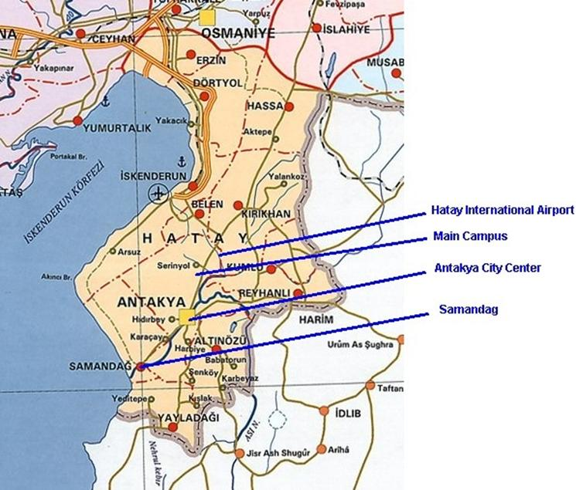

CLIMATE AND WEATHER CONDITIONS

It is generally warm in October in Antakya. The average temperature is about 20-25ºC at daytime and 10-15ºC at night. Rain could be expected.

CURRENCY

The currency in Turkey is Turkish Lira (TL). Other currencies including Euro and USD can be exchanged in currency exchange shops or in banks located in the city center. Most shops usually accept payments in Euro and USD. As of July 2015, 1 Euro is about 3.00 TL and 1 USD is about 2.70 TL.

ACCOMMODATION

The guests can choose one of the places below.

1) MKU Guest House (**/***) (will be booked by the MKU Erasmus Office)

Our university has a guest house in Antakya city center located on the main street (Ataturk Street). It has 25 rooms. All rooms have TV and bathroom inside. The guest house also has a small restaurant in the first floor. Breakfast, lunch, and dinner are served in the guest house.

As of July 2015, the price is about 50-55 TL (about 15-20 Euros) for a single room and 65-70 TL (about 20-25 Euros) for a double room per night (including breakfast and taxes). (1 Euro = 3.00 TL)

Address: Mustafa Kemal Üniversitesi Rektörlük Misafirhanesi, Atatürk Caddesi, 31040 Antakya, Hatay
(Mustafa Kemal University Rectorate, Guest House, Ataturk Street, 31040 Antakya, Hatay)

2) Narin Hotel (****) (has to be booked by the participant)

Narin Hotel is on the main street (Ataturk Street) in the city center close to many restaurants and a big shopping mall (Palladium shopping mall).

The price for Single Room is about 135 TL (about 45-50 Euros)
The price for Double Room is about 200 TL (about 65-70 Euros)

Address: Atatürk St. No:11 Antakya, Hatay
Phone: 0090 326 216 7500
Web: www.narinhotel.com
E-mail: info@narinhotel.com

CONTACT INFO:

Address: Mustafa Kemal University Rectorate
International Relations & Erasmus Office
Tayfur Sokmen Campus
31040 Antakya, Hatay, Turkey

Phone: +90 326 221 5815 (Within Turkey: 0 326 221 5815)

Fax: +90 326 221 5815 (Within Turkey: 0 326 221 5815)

E-mail: erasmus@mku.edu.tr, mkuerasmus@gmail.com

Internet: MKU Faculties and Departments Course catalog: http://bbs.mku.edu.tr
MKU International Office: http://int.mku.edu.tr
MKU main web page: http://www.mku.edu.tr

<end>

